CSS MEANS CASCADING STYLE SHEETS
HELPS WITH DESIGN, LAYOUT, AND EVEN THE VARIATIONS OF DISPLAY FRO DIFFERENT DEVICES.
WITH AN EXTERNAL STYLESHEET, WE CAN CHANGE MULTIPLE PAGES WITH JUST CHANGING ONE FILE
ALL THIS MUST BE INCLUDED INSIDE AN <STYLE></STYLE>, INSIDE HEAD.
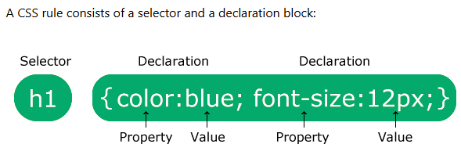

Selector is the element we want to style, inside the declaration, one or more declarations are separated by semi colons. Inside them, declarations are in name: value pairs. Declaration blocked marked by curly brackets.
p {
color: red;
text-align: center;
}
-CSS SELECTORS:
Are used to find which elements do we want to style. CSS Selector selects elements based on their names. We can also use ids instead of name, but then we have to ass # in start. For classes, there name should begin with “.” In the name of the selector. We can also use multiple class names at once.

Two properties I have learnt till now are color, and text-align. Now background-color and font-size.

UNIVERSAL SELECTOR * will affect all elements on the page. Every element.
* {
text-align: center;
color: blue;
}
A grouping selector can also be used when more than one element has the same style, then why use them separately.
h1, h2, p {
text-align: center;
color: red;
}
code challenge for selectors remains

-WE CAN ADD CSS FILES IN THREE WAYS:
1)External CSS, by linking to an external .css. With this we can change multiple pages with one, html page must have reference to CSS inside the head through link.
2)Internal by using style in the head section.
3)Inline, by using css inside the line through style etc.

-EXTERNAL: <link rel="stylesheet" href="mystyle.css"> put this inside the head to link the html to a css stylesheet. For this we make a file with the extension .css and add it through link.
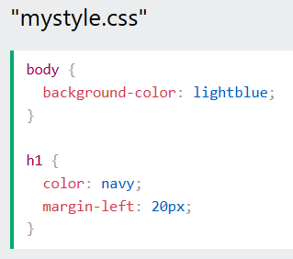

-INTERNAL: is just a style tag inside the head of the file.
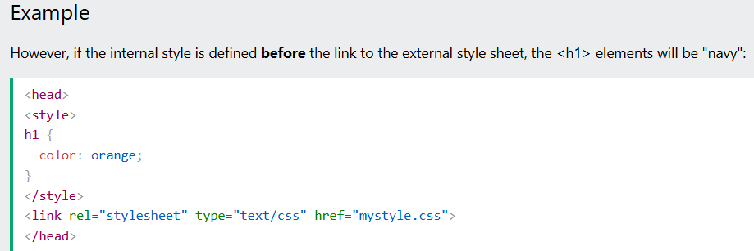
And vice versa. IF THERE ARE MULTIPLE STYLE SHEETS IN ONE PROGRAM, THEY WORK ON BASIS OF PRIORITY, INLINE FIRST, THEN EXTERNAL/INTERNAL AND THEN BROWSER DEFAULT. THE CONDITIONS REGARDING EXTERNAL/INTERNAL ARE DESCRIBED ABOVE (last rule loaded).
We can even make changes to HTML tag and it will cover entire code!!!
-COMMENTS: /*ffff*/ (remember for html comments, <!- -comment -->

-COLORS:
Use color: and background-color:
We can also add and color border to text, such as <h1 style="border:2px solid DodgerBlue;">Hello World</h1>
WE can use rgb(255,255,255) instead of a color name and if we want things like transparency, we use rgba, that adds a alpha element to red, green, blue. The alpha is invisible at 0 and full color at 1.
We can use hexadecimal codes for colors, #ff00ff.
We can use HSL (hue 0-359, saturation %, lightness %). Saturation is the shade of grey. There is also HSLA which also has the alpha for transparency.

-BACKGROUND:
Background-color is same as I have learned, give it a color. We can also have another attribute, opacity 0-1 that takes same values and works same as alpha in rgba
Background-image can take the image URL as input.
Background-repeat is used to handle how the image will repeat in the page. Such as we can give it “repeat-x” to only repeat horizontally, or we can give it “no-repeat” to not repeat at all.
Background-position can be given where we want the image to display, such as “right top”
Background-attachment is used to decide whether the image scrolls or stays fixed when the page is scrolled. It can be given scroll or fixed.
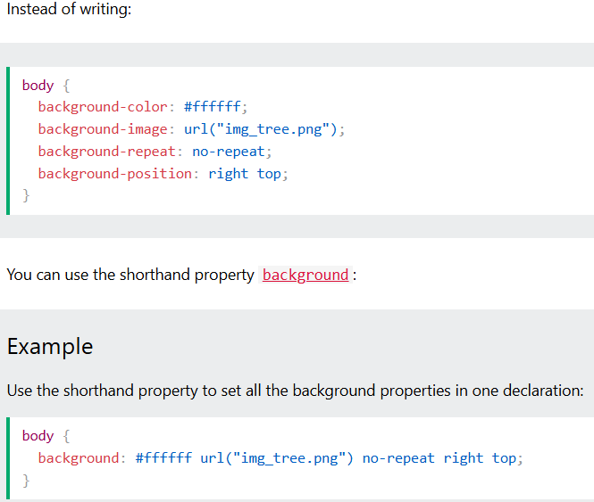
This is the shorthand, background
Property.

-BORDERS:
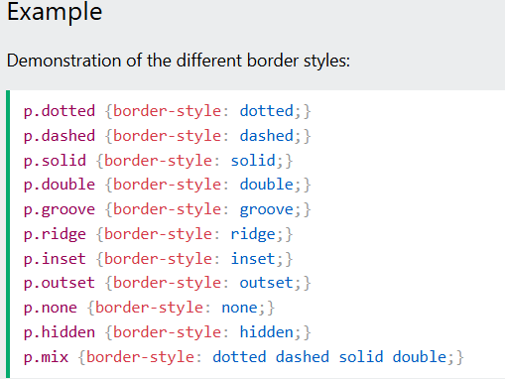
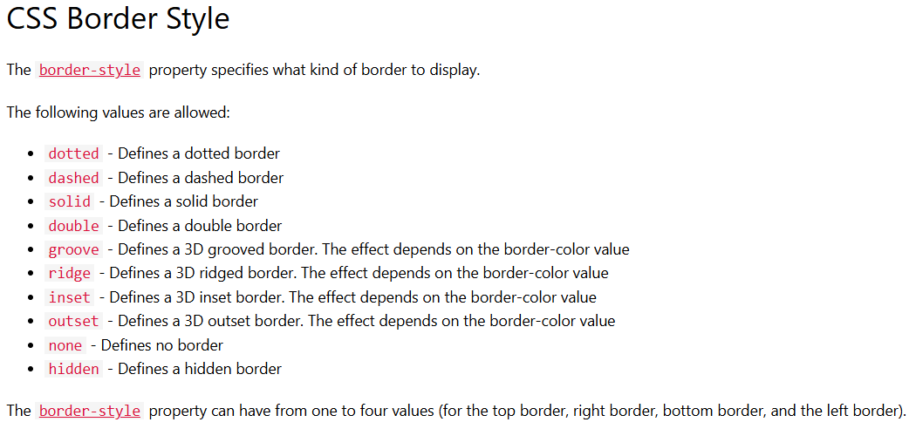

THERE is also the border-width property that can take either px, medium, thick, etc.
If we give more then one size, it counts as top, right, bottom, left, each having individual size.
We can also use border-color property, and similarly if we give it four colors, it will apply as such.
We can also give more then one border style. If we give three, it will count top, sides, bottom. Or we can use the individual properties, such as border-bottom-style etc.
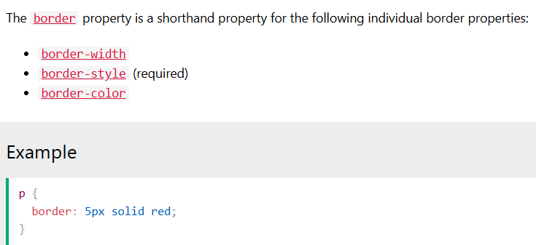
we can simply use this one, such as border-left with these three and we will get the border similar to that green left border in this picture.
Border-radius is the property we use to make borders rounder, giving them a radius such as border-radius 5px.

-MARGINS:
Margins are used to make space around the elements, outside of any defined borders. Margins define the distance between an element’s borders and the surrounding elements.
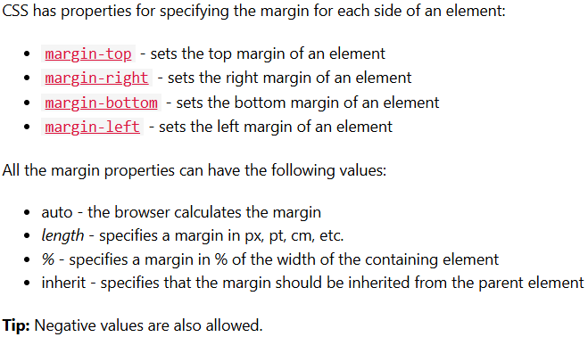

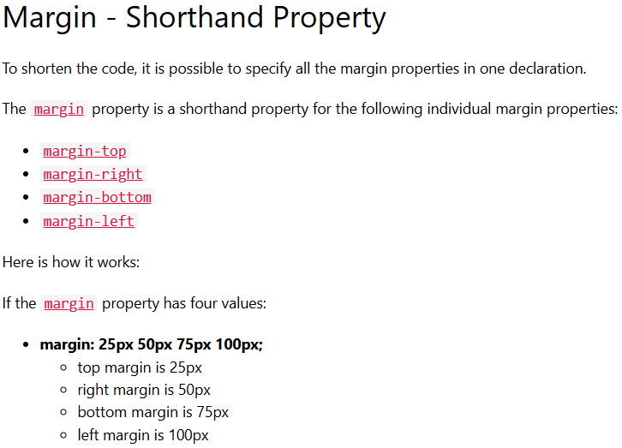
DONE TILL MARGIN COLLAPSE.
.
.
.
.
.

